**| INDEX |**

|  |  |  |
| --- | --- | --- |
| **Sr No.** | **Topic** | **Page no.** |
| 1 | Explanation on how the fluid domain is generated and governing equations used. | 3 |
| 2 | Explanation on the strategy used to mesh the domain. | 6 |
| 3 | Explanation on how the Simulation is set up in the CFD solver. | 9 |
| 4 | Explanation of the boundary conditions used. | 13 |
| 5 | Explanation of the solver settings used to run the simulation. | 17 |
| 6 | Post process the simulation to obtain key features of the flow field. | 21 |
| 7 | What specific skills did I use during this project/task, and how did they contribute to the outcome? | 29 |
| 8 | What challenges did I encounter, and how did I overcome them? | 31 |
| 9 | Conclusion | 33 |
| 10 | References | 34 |

**Q.1 - Explanation on how the fluid domain is generated and governing equations used.**

* **Capsule Geometry Processes:**

Use the file CapsuleFlow.scdoc in Ansys SpaceClaim to import the geometry of the reloaded capsule.

Ensure that the geometry captures the main features of a simplified capsule structure suitable for simulating hypersonic flow.

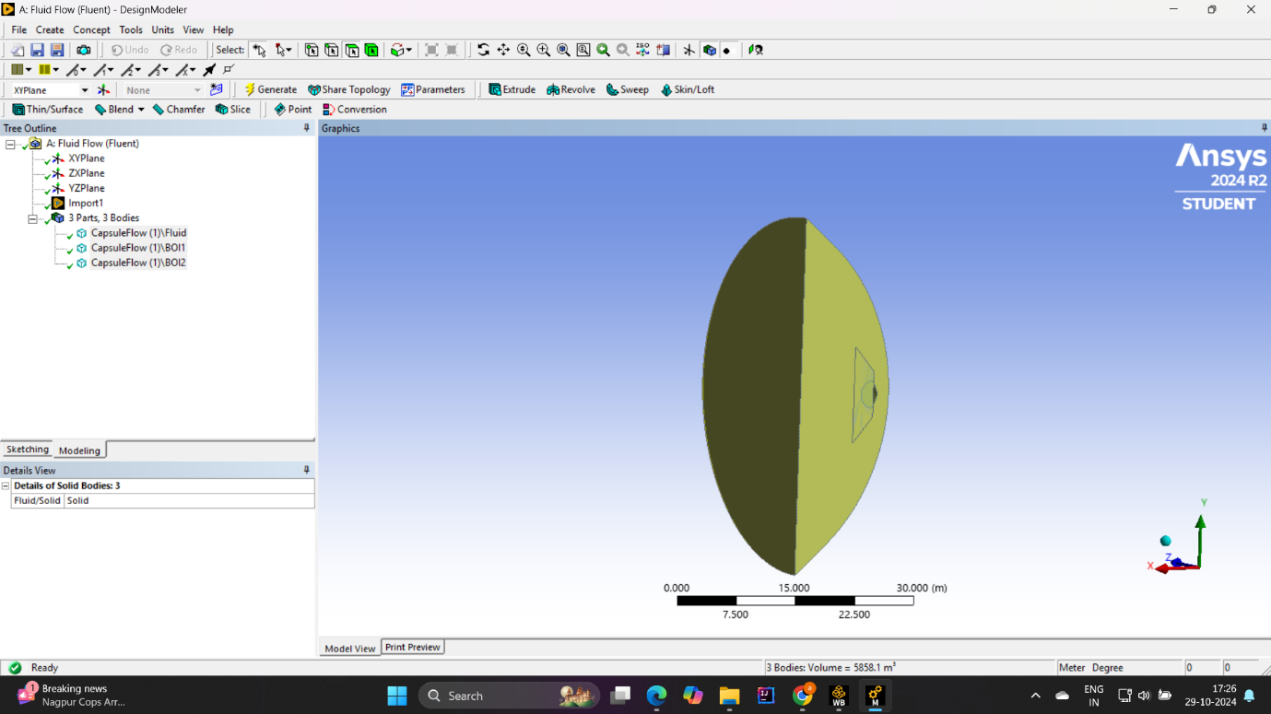

* **Definition of audit area:**

Define a circular or circular area around the capsule. The size of the domain should be large enough to avoid boundary effects, with a size of about 5-10 times greater than the diameter of the capsule.

Set domain boundaries to represent the far-field conditions of the hypersonic re-entry scenario, such as the free flow velocity, pressure, and temperature at the inlet.

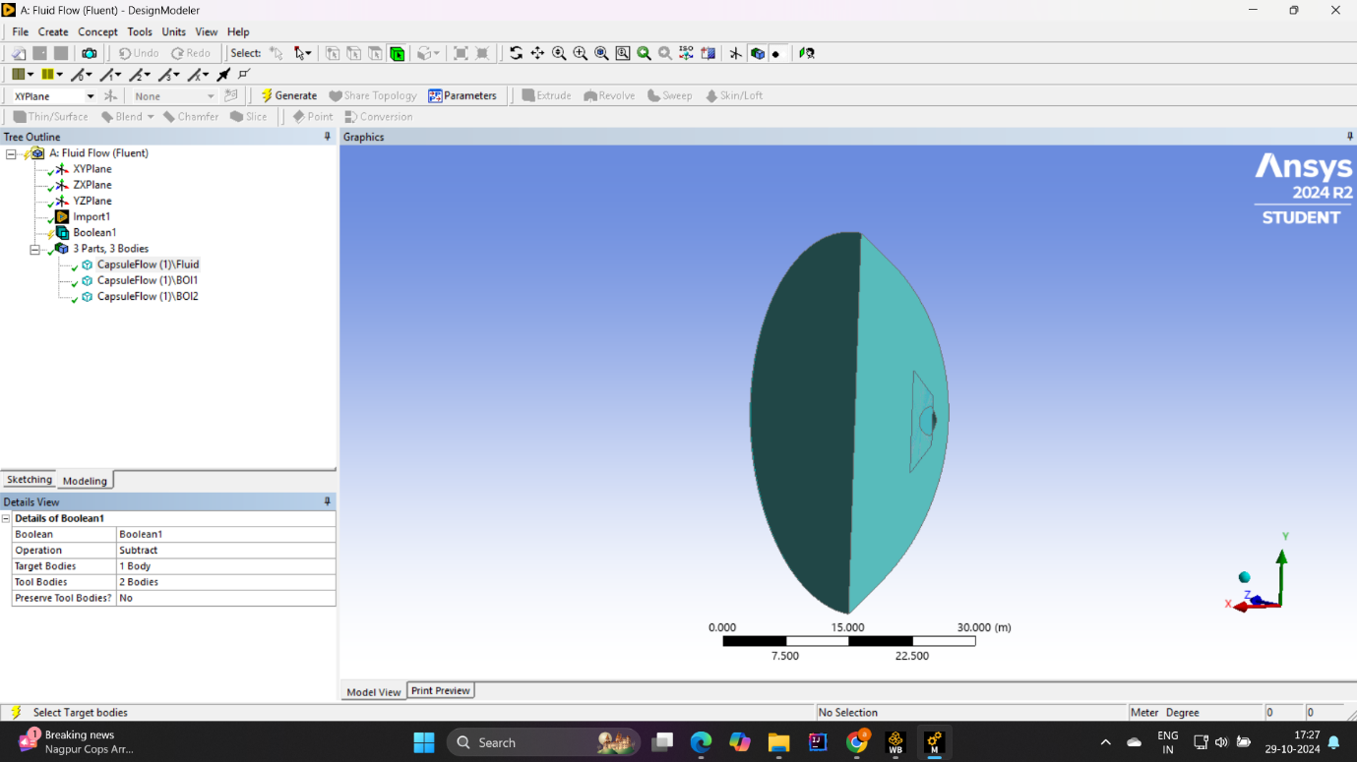

* **Governing Equations :**

1. **Continuity Equation:**



**Where :**

t = Time

ρ = Fluid density

u = flow velocity vector field.

1. **Momentum Equation:**

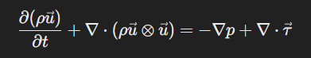

**Where :**

ρu represents the momentum per unit volume.

∇p\∇p is the gradient of pressure, acting as a force on the fluid.

τ⃗\τ is the viscous stress tensor, representing internal friction forces within the fluid.

f⃗\f​ is an external body force, often ignored in high-speed aerodynamic simulations.

1. **Energy Equation :**

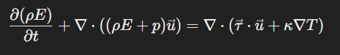

**Where :**

E is the total energy per unit mass, defined as E=e+1/2u ,where e is the internal energy and 1/u2 is the kinetic energy.

κ is the thermal conductivity.

T is the temperature.

1. **Equation of State**

**p=ρRT**

**Where :**

p is the pressure.

R is the specific gas constant .

T is the temperature.

In a hypersonic reentry scenario, where Mach number is quite large

The effects of compression are significant.

Shock waves form around the capsule, causing dramatic changes in pressure and temperature.

The energy equation is important to capture these thermal effects.

**Q.2 - Explanation on the strategy used to mesh the domain.**

* **Explain the software**

A circular or circular area is selected, extending several knob widths behind the wall. Typically, a domain size of 5-10 times the capsule diameter is used to avoid boundary interference.

The inlet boundary (free flow) is set far enough away from the capsule to produce a shock wave without interference from the boundary conditions.

* **Border networks**

Inflation layers: Inflation layers are added near the capsule surface to accurately capture the boundary layer. This region is important in supersonic flows due to steep temperature gradients and viscous effects. The inflation layer helps resolve the steep velocities and high temperatures that occur at the surface.

y+ value: A low Y+ value (usually around 1) is aimed at capturing the viscous substrate in the boundary layer. This helps to fine-tune flow characteristics such as skin abrasions and heat transfer.

Layer Increase: Inflation layers gradually increase in thickness away from the surface, typically using increments of 1.2 to 1.3.

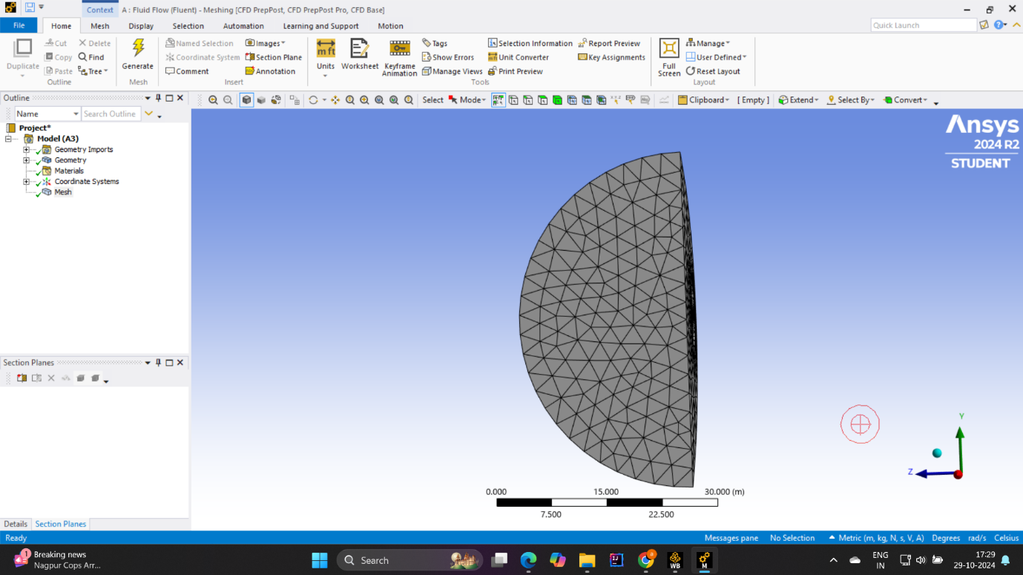

* **Shock capture in free flow**

Area preparation around the expected affected area: Strong impacts are created at the nose and capsule edges for hypersonic flow. The refinement region around the capsule nose is used to better capture these shocks. This region may extend slightly beyond the shock location, because the shock moves slightly depending on the Mach number.

Adaptive grids (if supported): In some cases, adaptive grids can be used to fine-tune regions where high gradients (such as near shocks) grow This ensures efficient use of computational resources.

* **Poorly organized communication that has been developed locally**

Unstructured grids (square or polyhedral) are often used around the capsule geometry to handle complex shapes. Local refinement is applied at high elevations, such as near the capsule surface and in the wake region.

Hexagonal or prismatic mesh for boundary layer: In some cases, a partially structured mesh with hexagonal cells or composed of prismatic cells can be used in the boundary layer region, as it provides better resolution and stability high-gradient regions

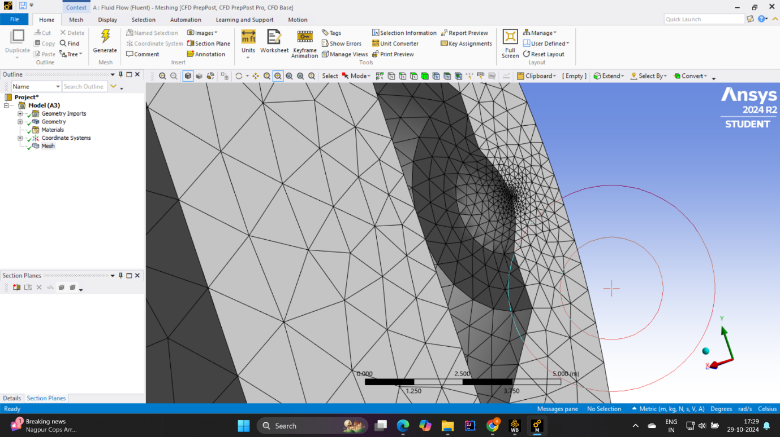

* **Awakening area network**

Extended mechanism on wake: A penetration correction area will be placed inside at the base of the capsule to accurately capture wake behavior. This helps to capture the flow separation and recirculation region outside the capsule, which is important for accurate drag forecasting.

Gradual smoothing: The mesh is gradually smoothed out in the remote region, balancing computational cost with an accurate solution.

* **All network quality metrics**

Aspect ratio: Keep the aspect ratio low, especially on slopes, to avoid unstable calculations.

Tilt: Reduce the tilt for better calculation accuracy, especially when close to impact.

Cell Counting: Use fine lines only where necessary (e.g., around and around the capsule) to produce adequate numbers of cells to ensure accurate counting without sacrificing accuracy.

**Q.3 Explanation on how the Simulation is set up in the CFD solver.**

* **Define physical**

Fluid Type: Select gas as the active fluid for all samples. Set it to the right wind to account for high-speed pressure.

Thermal characteristics: Give the air a temperature-based energy, as supersonic water can generate significant heat.

Viscosity model: For supersonic flows make sure the viscosity model is appropriate, usually using Sutherland's law for temperature dependent viscosity.

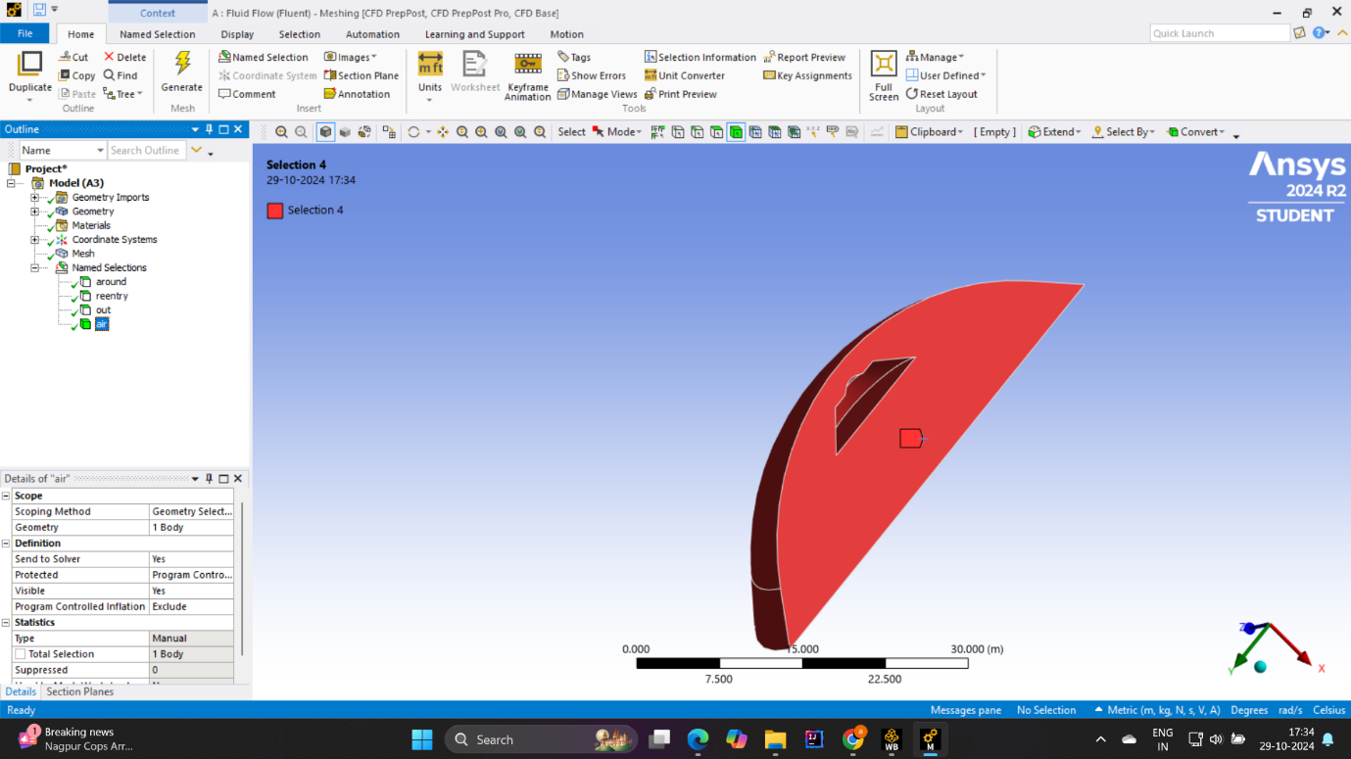

**( Air Selection )**

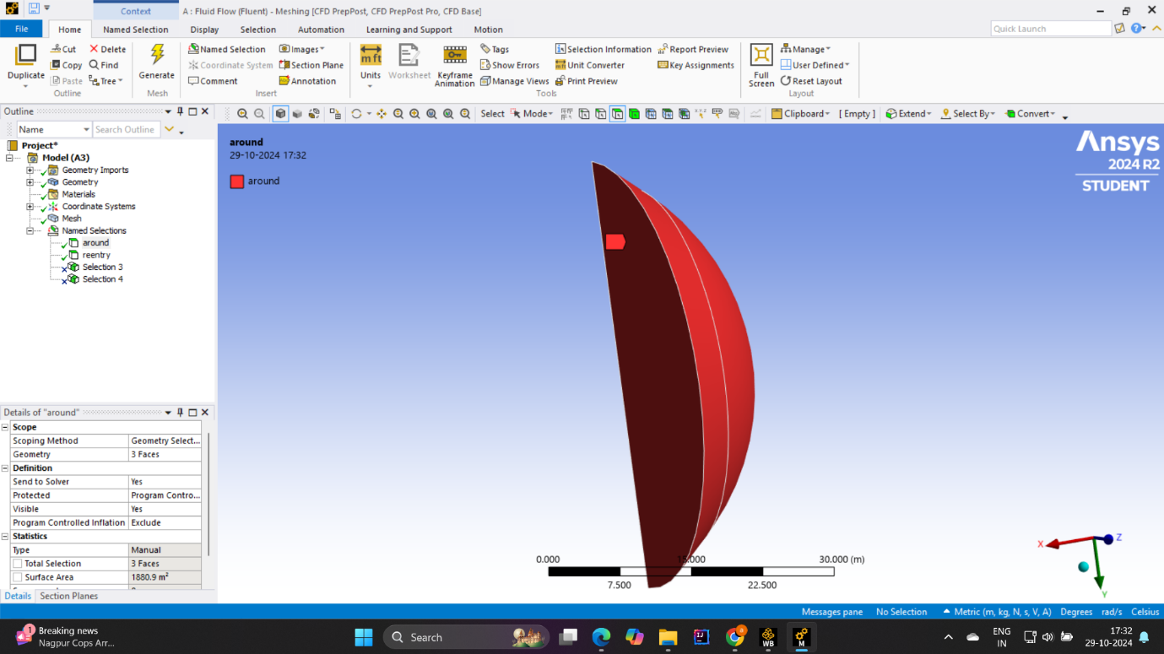

**(Around the re-entry model selection)**

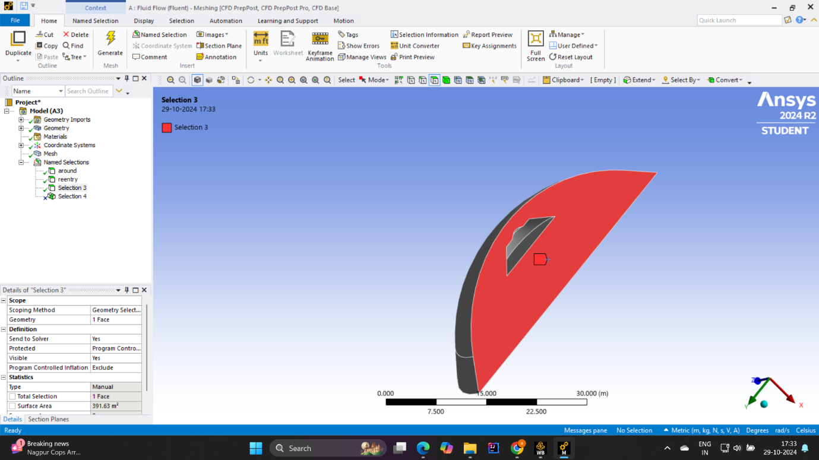

**(Outlet Selection)**

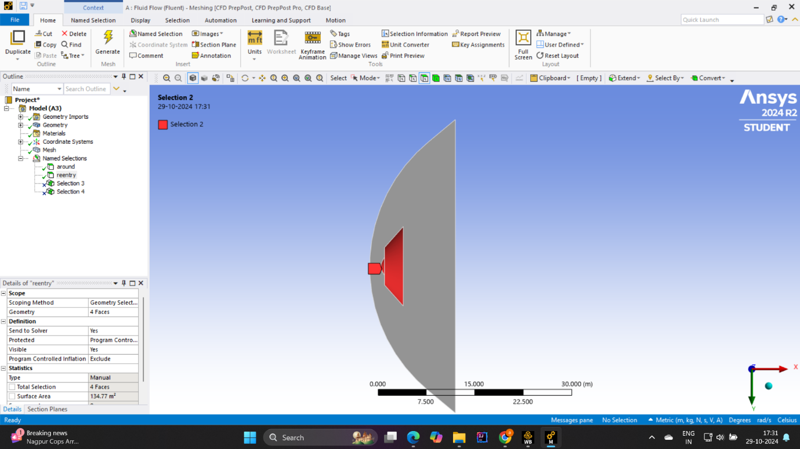

**( Re – Entry model selection )**

* **Flow and turbulence models**

Compressible flow model: Use the compressible flow option to capture density changes, which are important during supersonic movements.

Turbulence Model: Select an appropriate turbulence model, such as the SST (Shear Stress Transport) k-ω model, which is appropriate for horizontal regions such as boundary layers and shock-boundary layer interactions

High Mach adjustment: Some asolvers offer adjustments or settings to improve the accuracy of high match numbers (shock capturing or low dispersion schemes).

* **Solver programs**

Solver Type Use a density-based solver for high-speed compressible flow, because it handles shock waves more accurately than a pressure-based solver

Time Step: Select a static or transient solution as needed. The steady-state approach is common, but temporary structure may be needed for unstable shock behaviors.

Convergence criteria: Set convergence criteria for residuals (e.g., 1e-5 or lower) to ensure accuracy, and check integral quantities such as lift and drag coefficients to ensure accuracy

* **Mesh and domain structure**

Ensure that the mesh is properly formed around the capsule surface, wake, and expected trauma region.

Apply adaptive grid refinement (if available) for high gradient areas, especially around nose and shock areas.

* **initializing the solution and running the simulation**

Initiate maintenance based on free flow conditions.

Perform separate simulations for each Mach number case (2, 5, 10, and 17). Start with a low Mach number to ensure stability before moving to a higher Mach number.

**Q.4 Explanation of the boundary conditions used.**

* **Restricted Entry Conditions (Freestream) :**

**Type:** inlet pressure or inlet mach

**Mach Number Explanation:** To study the wind potential at different speeds, set the Mach number at the inlet to 2, 5, 10, and 17 individually for each simulation case

**Pressure and Temperature:** Determine the total pressure and temperature (stagnation) based on normal conditions for each Mach number. Both pressure and temperature levels must indicate the altitude or re-entry atmosphere.

**Compressibility Effects:** Since the flow is compressible, setting the Mach number and temperature will automatically determine the inlet velocity and density, allowing the solver to accurately capture the effects of compressibility

This boundary condition ensures that the supersonic flow approaches the capsule with a specific Mach number, simulating a high-speed reentry condition

* **Outlet limit position :**

**Type:** Pressure release

**Back Pressure:** Set the static pressure at the outlet to atmospheric pressure (or a specified lower pressure based on reentry height).

**Flow direction:** The outlet temperature causes the flow to deviate from the numerical path without reflecting or interfering with shock waves and waves generated around the capsule .

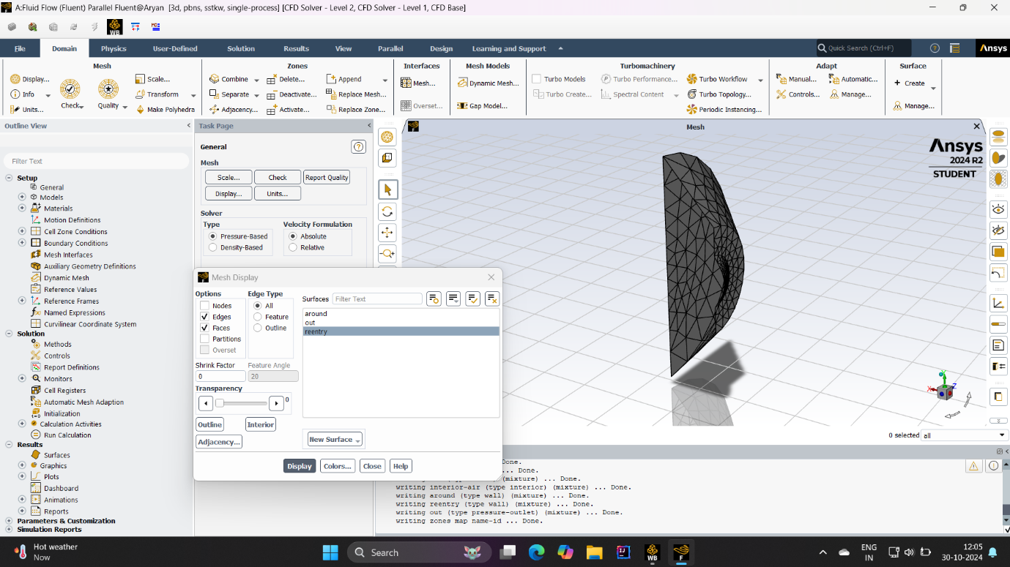

**( Main model )**

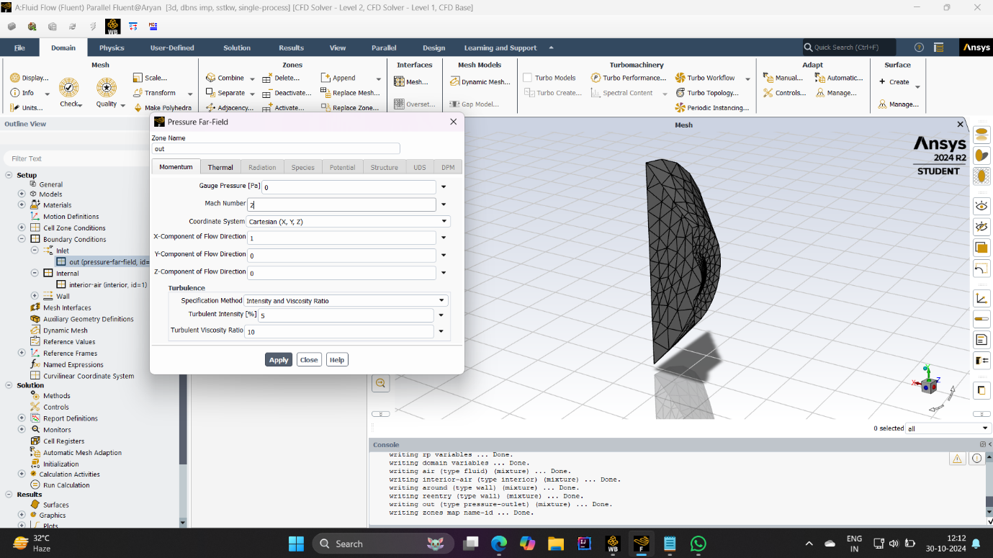

**(Mach 2 conditions)**

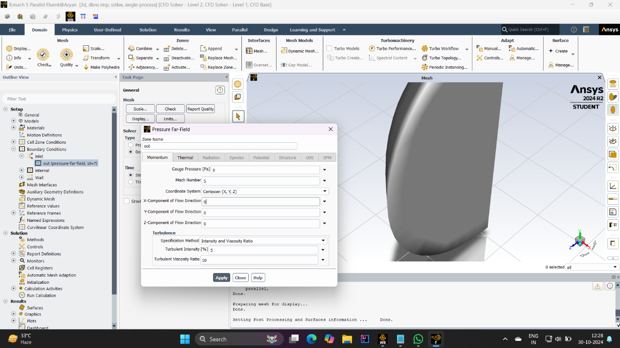

**(mach 5 conditions)**

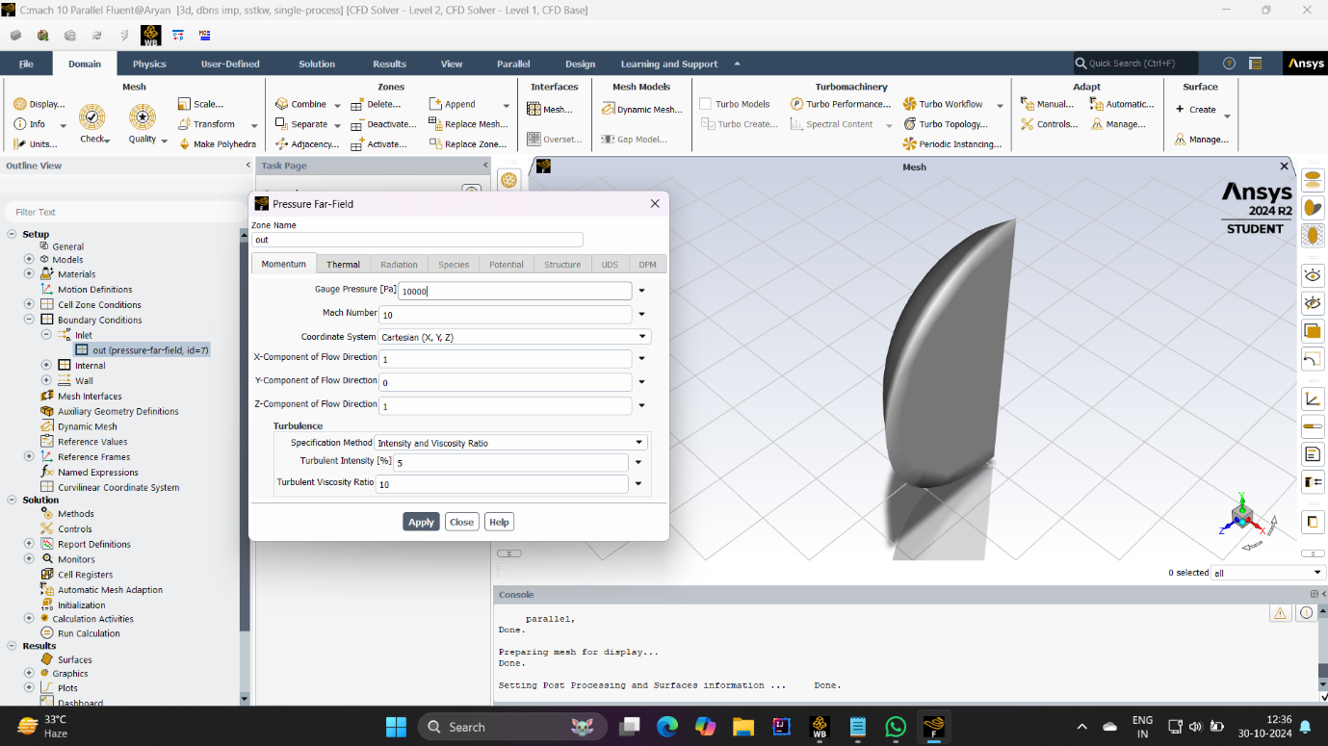

**(mach 10 conditions)**

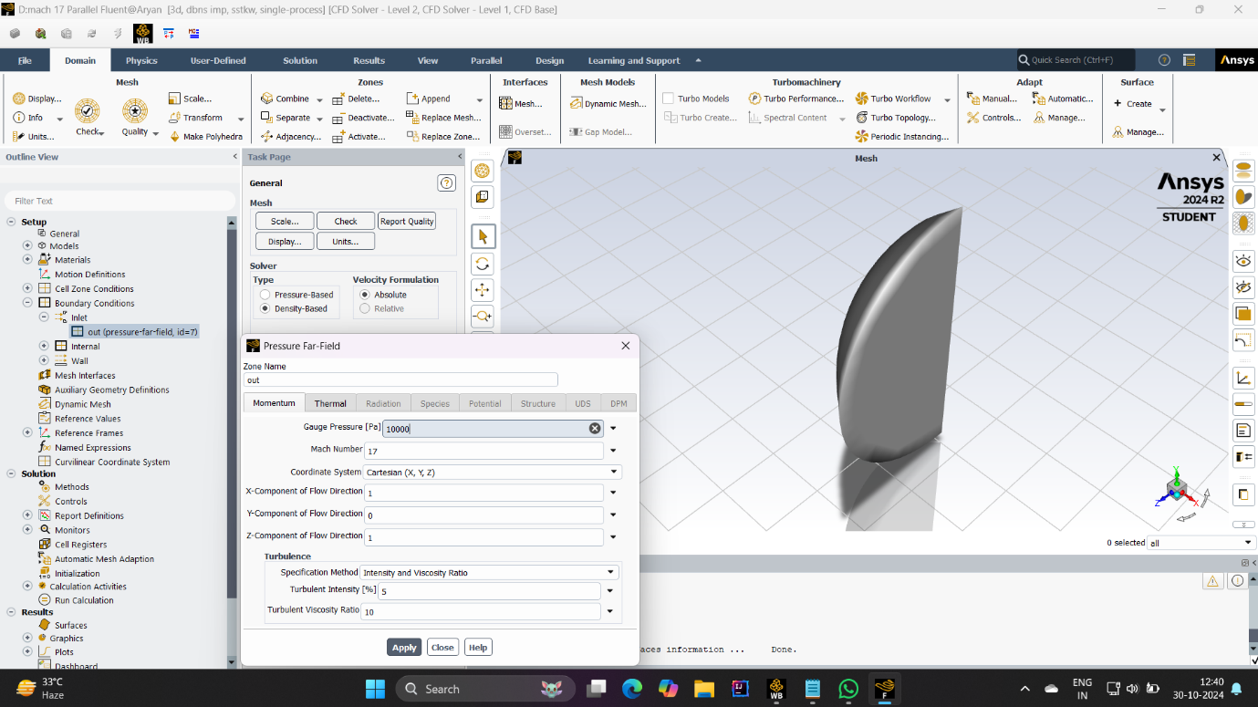

**(mach 17 conditions)**

* **CapsuleSurface (surface boundary condition) :**

**Type Wall (No-Slip)**

**Temperature conditions:**

Since supersonic flow generates a lot of heat, let the heat transfer to the surface of the capsule. You can specify a fixed wall temperature or use a heat flow boundary condition to simulate heat from friction.

This system helps capture aerodynamic temperature and thermal stress on the capsule.

Flow conditions: A no-slip condition is used, ie. the fluid velocity at the surface is zero. This boundary condition models the interaction between the supersonic flow and the capsule surface, taking into account effects such as friction and drag.

The wall boundary conditions at the capsule surface are important for accurate prediction of shear load, lift, and temperature on the capsule.

* **Far field (around the box) :**

**Type:** symmetry or far boundary

Pull away from the capsule: The far field boundary should be a few diameters away from the capsule to avoid any interference with the surrounding flow, especially the shock wave system

**Symmetry plane:** If the simulation is symmetric, the computational effort can be reduced by using the symmetry boundary condition. Otherwise, when simulating the entire 3D domain, set far-field conditions to simulate undisturbed free-flow flow.

The remote field boundary represents a stream of free flow conditions around the capsule, allowing the shock and flow fields to evolve naturally.

* **symmetry or axis :**

Use symmetry boundary conditions if the geometry or flow structure allows symmetry (such as a longitudinal plane through the center). This reduces computational requirements by modeling only half (or a quarter) of the domain without affecting accuracy.

**Q.5 Explanation of the solver settings used to run the simulation.**

* **Solver Type: Density-based configuration**

Why does it depend on density? Density-based solvers are preferred for high-speed compressible flows, such as supersonic re-entry, because they handle shock waves and high Match-number effects accurately Density-based method solves density-based equations, which are supersonic. It is important to capture changes in density due to pressure and temperature in flow

**Benefits:** This solver is optimized for consistency and accuracy in capturing the physics of shock waves, expansion waves and high temperature gradients

* **Hybrid initialization**

**Purpose:** Hybrid initialization is a method that provides initial estimates for flow variables (such as velocity, pressure, density, and temperature) throughout the domain

**How it works:** It uses a combination of algebraic and user-defined methods to generate complex equilibrium initial fields, which is particularly useful for complex simulations such as supersonic flows

**Advantage:** Hybrid initialization by initializing the domain with appropriate initialization values ​​helps the solver converge faster and reduces the risk of statistical instability at the beginning of the simulation

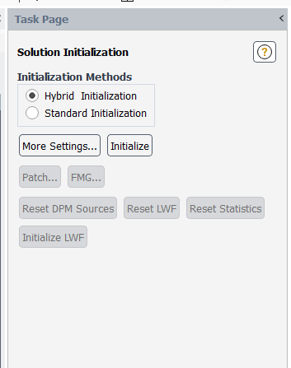

* **Number of settings to repeat**

Iteration Control: For each Mach number (2, 5, 10, and 17), you set a certain number of iterations for the solver to run. This allows the solution to proceed step by step until convergence or until the maximum number of iterations is reached.

Convergence criteria: The goal is to evaluate solution residuals (usually for continuity, momentum, energy, turbulence quantities) and ensure that they fall below certain limits (e.g., 1e-5 or lower) Additionally, evaluate parameters te that lift and drag coefficients to confirm the stability of the solution Helpful.

Typical iterations for convergence: For supersonic flows, convergence can take hundreds or even thousands of iterations depending on the complexity of the flow and the nature of the initial guess Setting a higher iteration threshold allows the solver to reach a solution that is den ho.

* **A cause of poor rest**

Changes in stability: Density-based solvers often change under-relaxation factors to control the effect of the solution of each equation on the next iteration, which improves stability If you start with lower relaxation factors at supersonic simulations to help achieve smooth convergence.

* **Remaining research**

Check residuals: During the iteration process, find the residuals of each governing equation (mass, momentum, energy, etc.). A steady decrease in the residuals indicates that the solution is converging.

Stop check: If the residuals are flat or reach the convergence threshold of the target, the simulation can be stopped earlier.

* **Solution Data Output**

Interim results: Save solution data periodically to analyze convergence trends, especially for quantities of interest such as lift and drag coefficients.

Post-processing: After completing the simulation for each Mach number, extract results such as pressure distribution, temperature, and wind speed for further analysis

Running the simulation sequence:

Start simulation: For each Mach number case, run the solver with a predetermined number of iterations.

Check convergence: Check that the solution continues to convergence. If necessary, adjust the number of iterations or the under-relaxation factor if the solution is stable.

Calculate the lift and drag coefficients: After convergence, extract the aerodynamic coefficients, which are important to understand the performance of the capsule at different match numbers .

**Q.6 Post process the simulation to obtain key features of the flow field.**

* **March number 2**

**Plotting Key Features:**

Pressure Distribution: Make a contour plot or graph of the pressure distribution around the capsule to visualize shock formation and pressure gradients. This will reveal areas of high pressure near the capsule edge and low pressure downstream.

**Pressure Theory:**

Anterior Pressure: Measure the pressure outside the capsule, especially on the nose where the stand rests, as it is often the area of ​​the greatest pressure

Wake Zone: Measure wake pressure to monitor flow separation and reconnection.

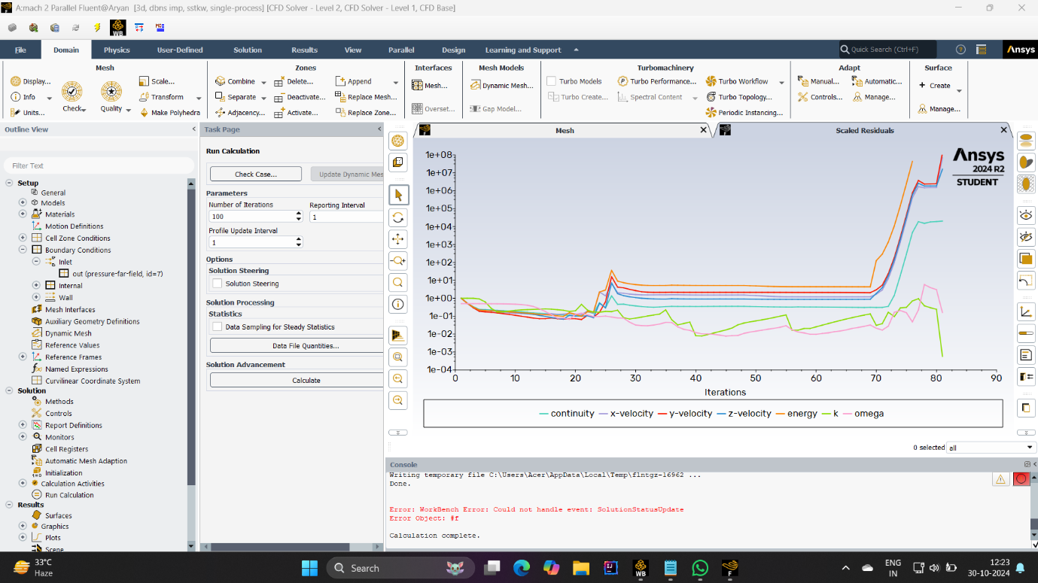

**(Graph of mach 2)**

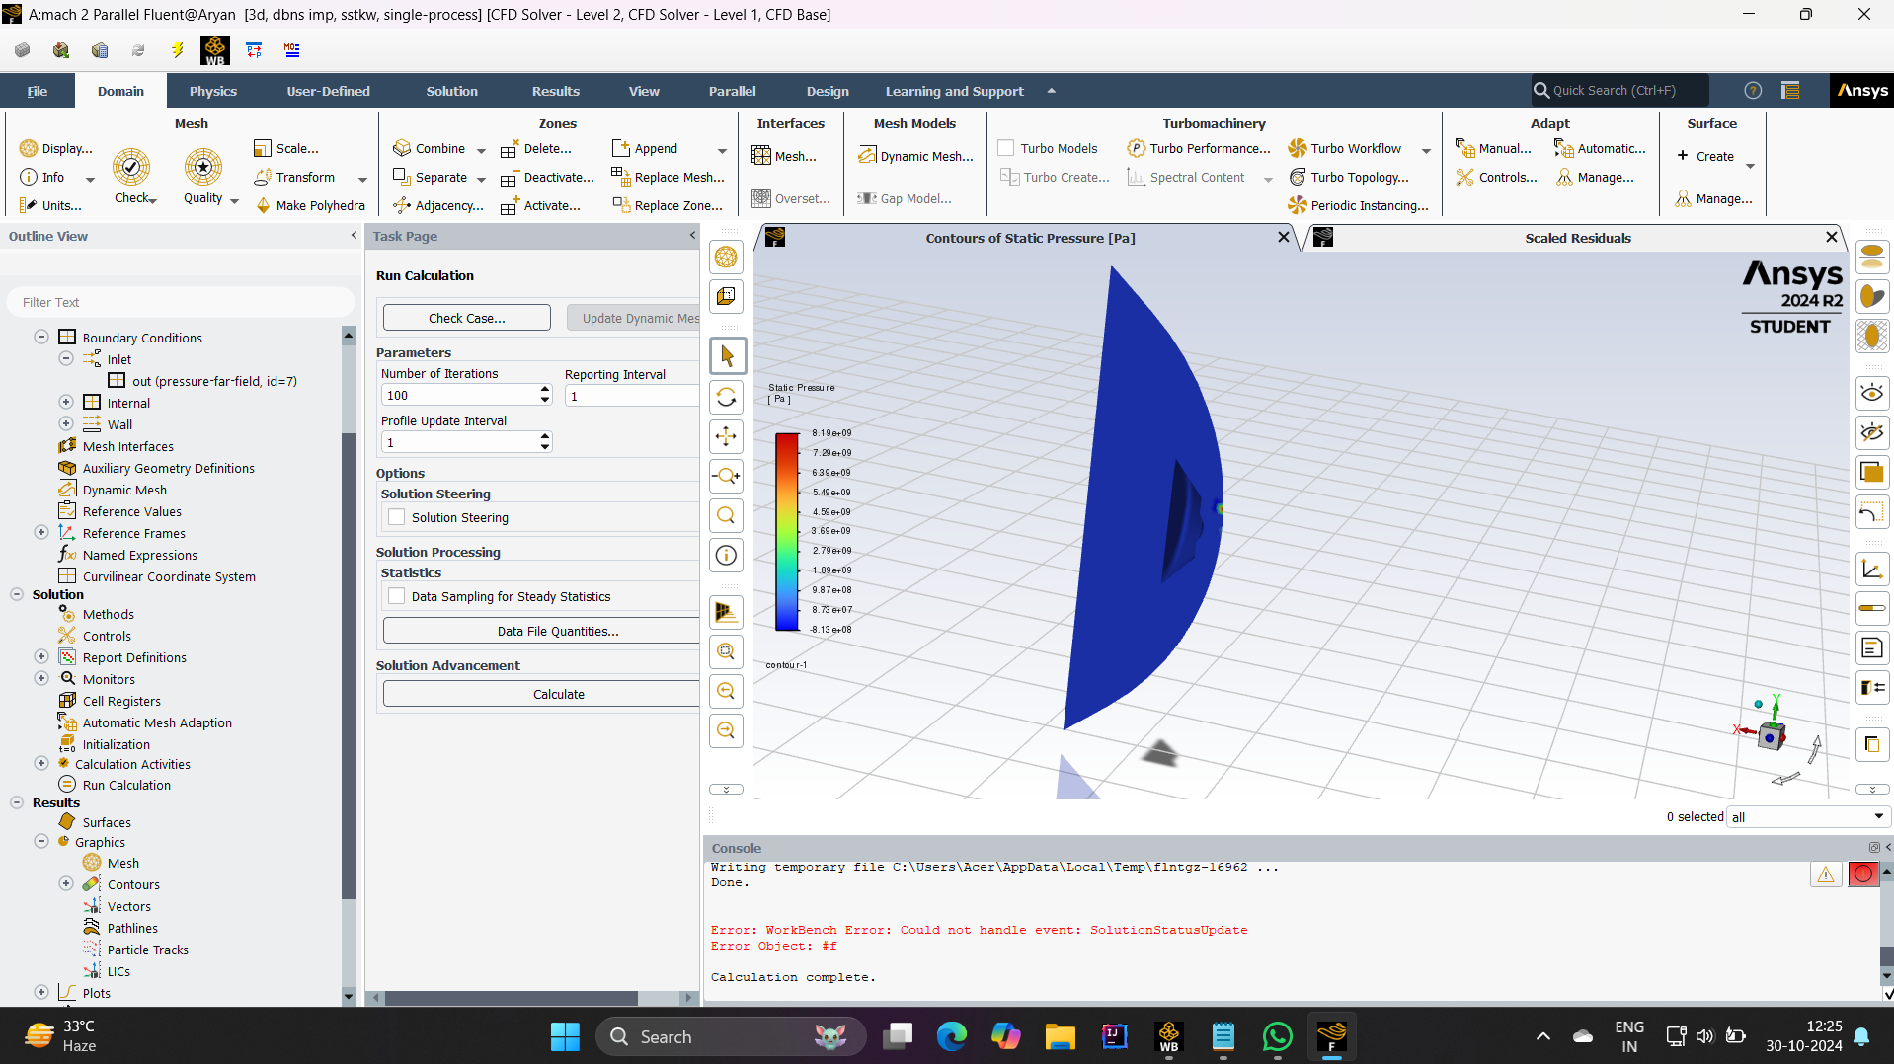

**( Pressure )**

* **March number 5**

**Plotting Key Features:**

Pressure Distribution: Make a contour plot of the pressure around the capsule. At Mach 5, the shock wave will be stronger and closer to the surface of the capsule, which means a higher pressure gradient.

Shock Wave Visualization: Use the plot to show the location and angle of the shock wave relative to the capsule.

**Pressure Theory:**

Stagnation pressure: Measure the pressure at the stagnation point and compare it to Mach 2. This pressure will increase exponentially as the dynamic pressure increases.

Pressure drop over the entire shock: Measure the pressure immediately before and after the shock wave to determine the size of the bubble in compression.

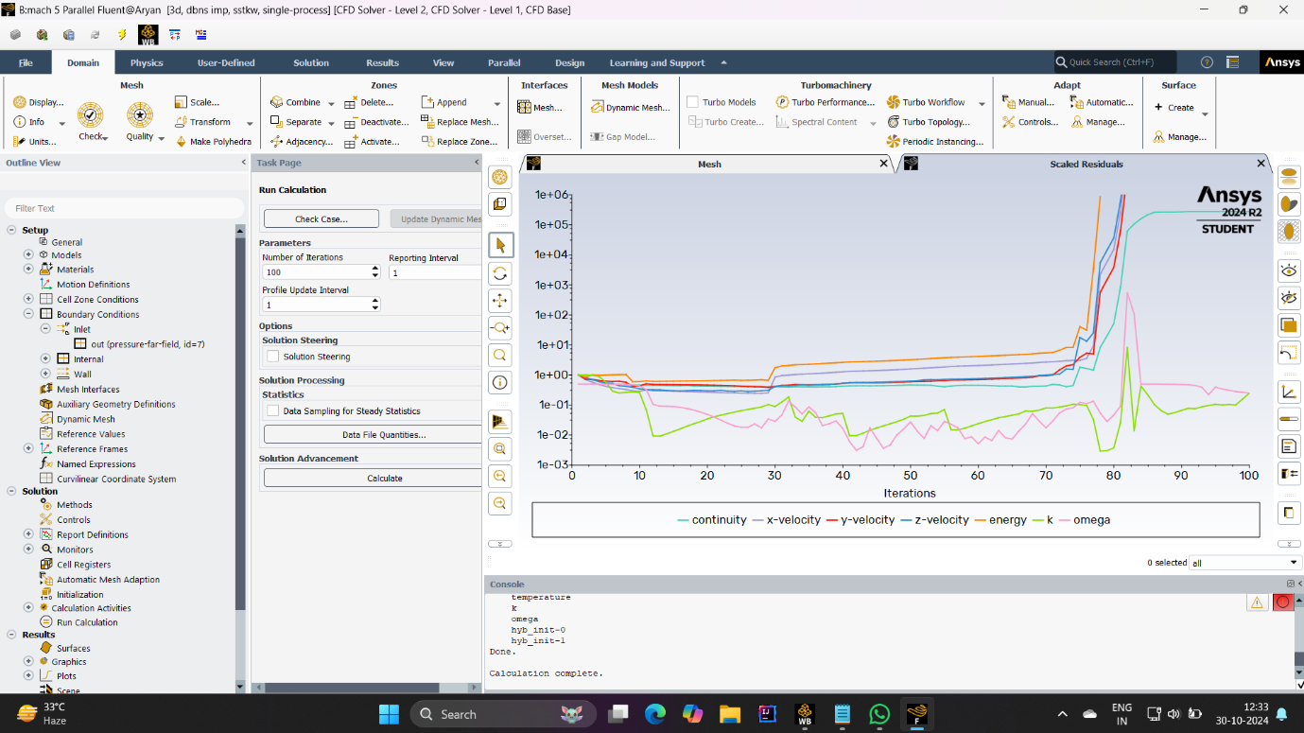

**(Graph of mach 5)**

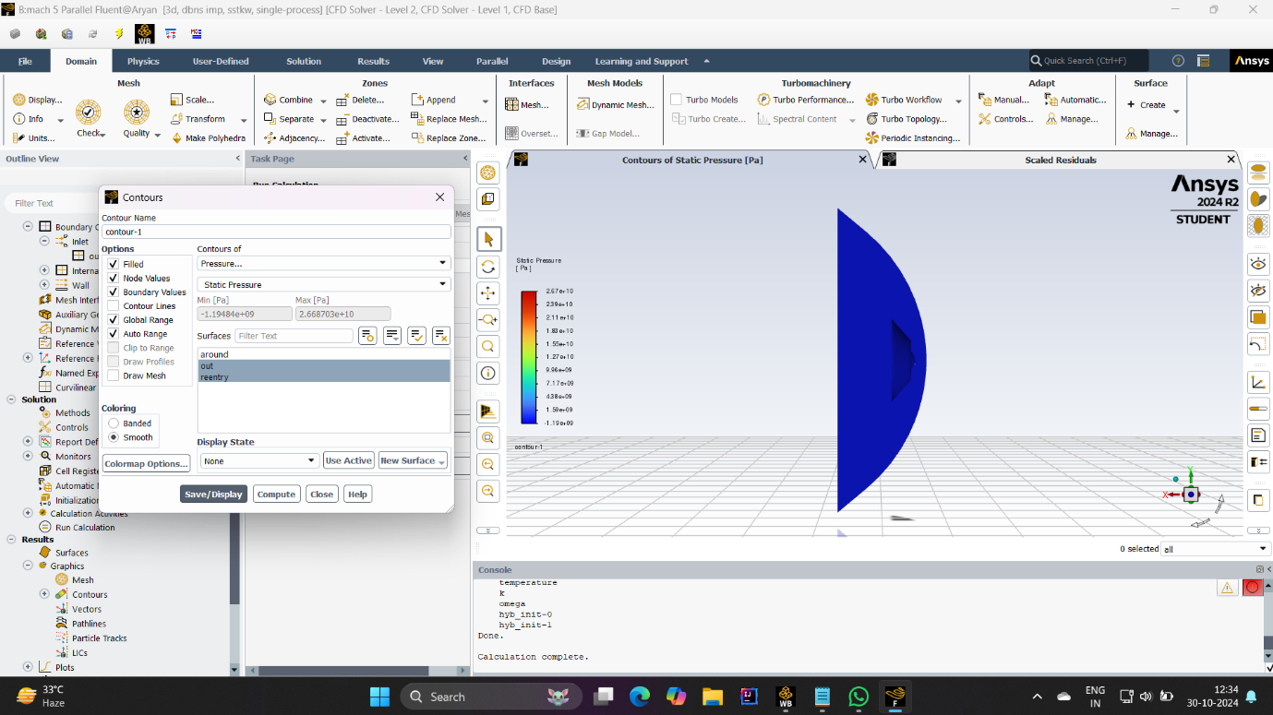

**( pressure )**

* **Mach No 10**

**Plotting Key Features:**

Pressure distribution: Create a contour plot to capture sharp shock waves and high pressure levels around the capsule.

Heat Transfer Considerations As the effects of supersonic heating become more important, the plot may show areas of strong pressure and high temperatures.

**Pressure Theory:**

Posterior capsule pressure: Measure pressure gradients in the nose and mouth. At Mach 10, the pressure increases and the boundary layer decreases, causing the gas temperature to increase.

Wake Pressure: Measure downstream pressure to capture expansion regions and specific flow separation.

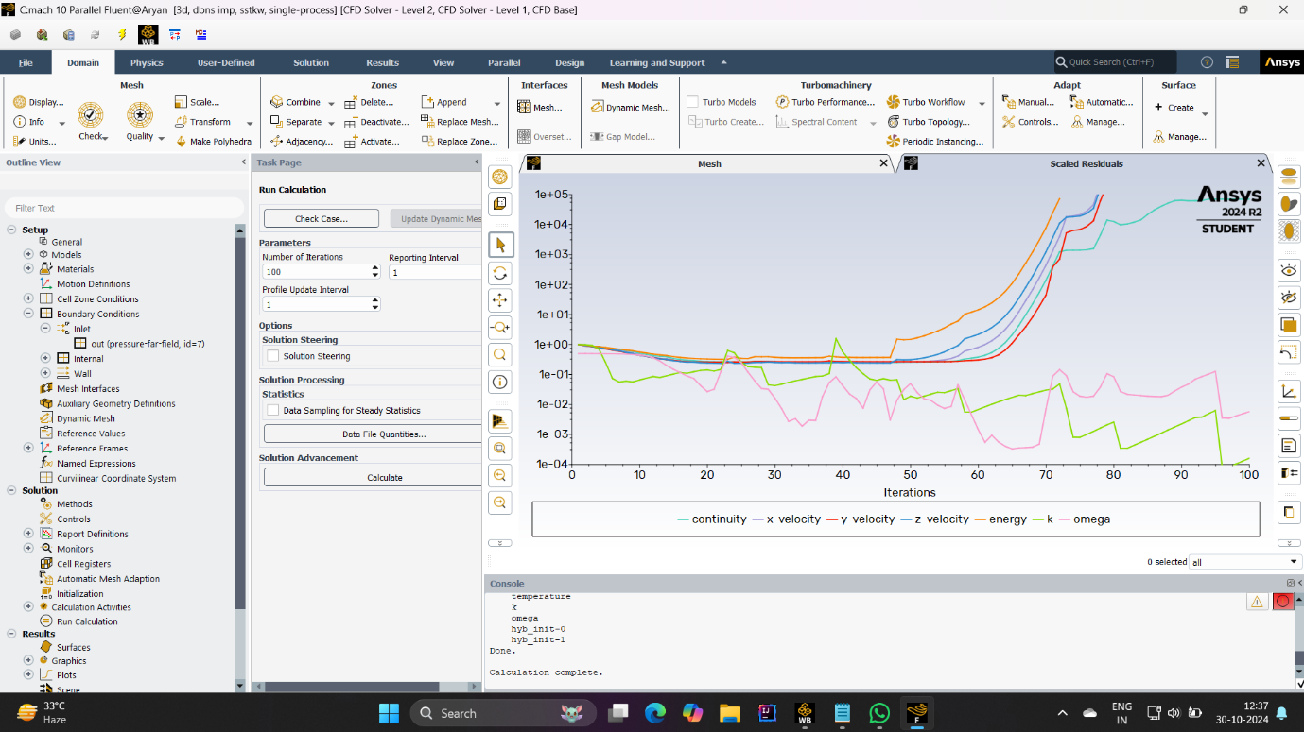

**( Graph of mach 10)**

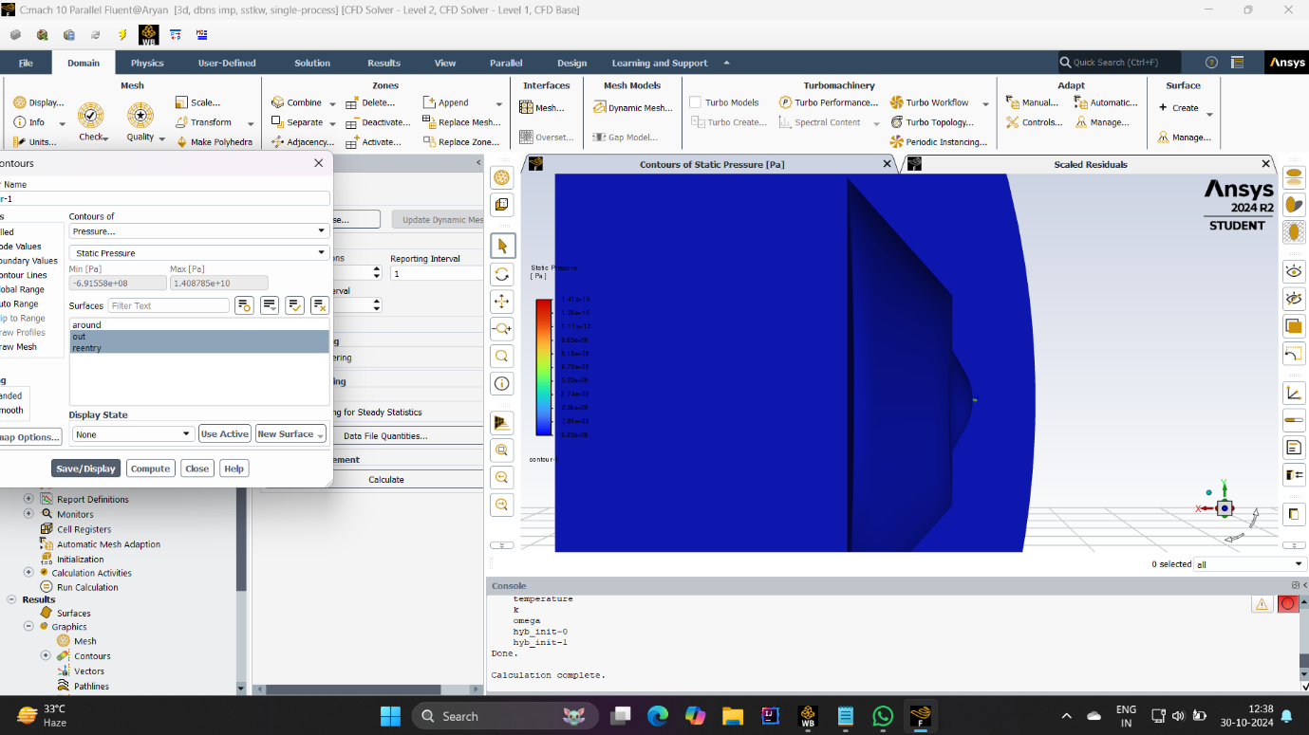

**( Pressure )**

* **March number 17**

Plotting Key Features:

Pressure distribution: Make a pressure contour plot for Mach 17. This plot should show the highest pressure values ​​at the stagnation point, with a clear shock wave near the capsule surface

Shock-layer compression: At this Mach number, the shock layer is very thin, with very high compression near the surface.

Pressure Theory:

Stability Point Pressure: Measure the maximum pressure in the nose to identify extreme conditions that are typical for high-speed returns.

Pressure at shock-wake regions: Compare all shock-wake pressures to assess flow stability and identify regions where thermal stability will occur.

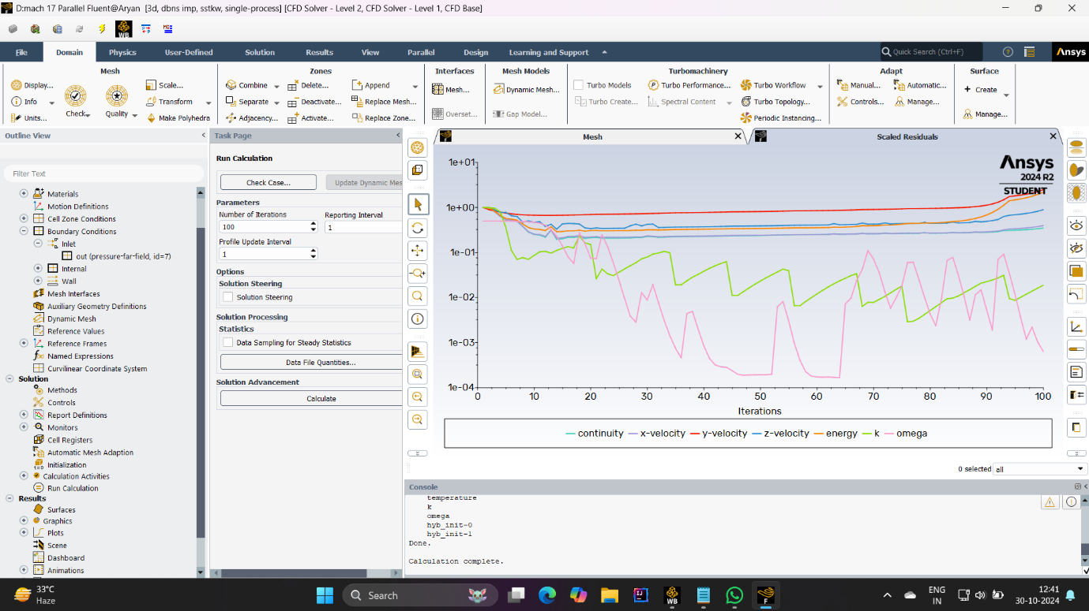

**( Graph of mach 17 )**

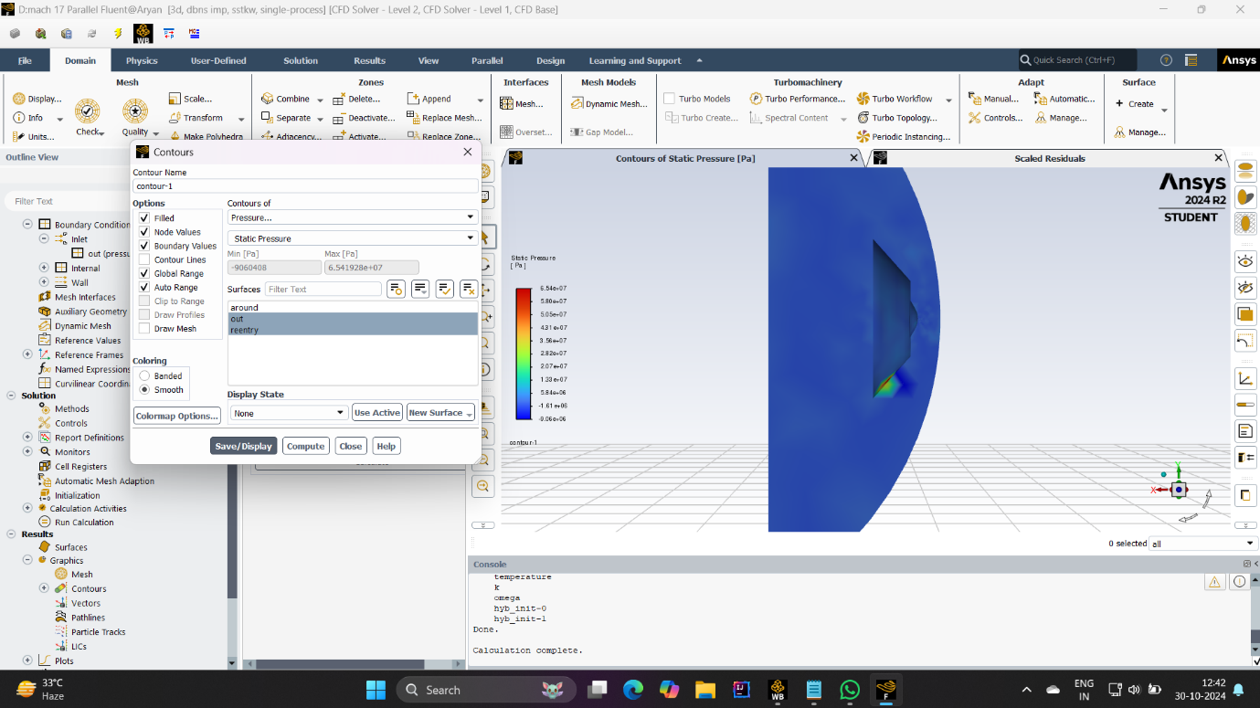

**( Pressure )**

**Self-Reflective Questions :**

1. **What specific skills did I use during this project/task, and how did they contribute to the outcome?**

* **CFD simulation setup and configuration**

Skills: Knowledge of CFD principles and experience with solver programs.

Contribution: By carefully choosing a density-based solver and setting boundary conditions for each Mach number, you ensured that the simulation accurately represents the supersonic flow characteristics around the capsule This procedure is important and for capturing shock waves, boundary layer behavior and aerodynamic forcing .

* **Geometry and domain definition**

Skills: CAD modeling and domain planning.

Contributions: Designed or introduced a simplified reentrant capsule geometry and defined an appropriate flow zone around it. This skill was critical to ensure that the geometry matched real-world conditions and that domain boundaries could capture realistic flows without artificial boundaries interfering with the simulation .

* **Meshing process**

Skills: Proficiency in meshing techniques, especially for hypersonic flow applications.

Contribution: Implemented mesh techniques, including fine mesh refinement and shock regions near the capsule surface, to obtain detailed shapes of the flow gradient This level of accuracy is necessary to capture high pressure and temperature gradients associated with supersonic velocities exactly .

* **Limit Situation Processing**

Skill: Establishing realistic boundary conditions for high velocity compressible flows.

Contribution: By setting the entry conditions and appropriate exit wall conditions for different match numbers you ensured that the boundary conditions reflected the real world conditions of re-entry This directly affected how to lift and the accuracy of the drag coefficient, and thus the aerodynamic performance The results have been reliable for weighing.

* **Post-processing and data analysis**

Skills: Ability to interpret simulation data, create contour plots, and measure relevant parameters such as pressure distribution.

Contribution: You thoroughly analyzed the simulation results, extracting reasonable data for each Mach number. By plotting the pressure distribution and comparing the lift and drag coefficients, you gained valuable insight into the aerodynamic behavior of the capsule at different speeds This study is important to understand the flow field and the influence of a velocity obtains on shock boundary layer characteristics.

* **Attention to detail and repetitive problem solving**

Skills: Rigorous testing and modification of parameters based on convergence and consistency.

Contribution: Your attention to detail in repeating a sufficient number of choices and searching for residuals ensured that the solution was accurate. This iterative approach allowed adjustments as necessary, especially at high match rates where convergence can be difficult. Your attention to consistency and consistency directly contributed to the reliability of the final result.

* **Technical Communication**

• Skills: Ability to document and explain technical aspects of design, boundary conditions, and interpretation of results.

• Contribution: Documenting and explaining your process in terms of configuration choices, boundary conditions, and interpretation of results made the project clear and repeatable These communication skills are essential to discuss project findings, especially if they are shared with others or included in standard reports.

1. **What challenges did I encounter, and how did I overcome them?**

* **Challenge: More complicated superpurity flow physics**

Issue: Simulating the supersonic flow requires consideration of complex phenomena such as shock waves, large temperature gradients, and density variations These effects are most pronounced at Mach in high numbers and requires careful solver selection and configuration.

Solution: You overcame this by choosing a density-based solver, which is designed to better manage compressible flow and shock formation. This choice ensured that the solver could control the velocity of the particles and capture important flow features around the capsule, even at Mach 17 .

* **Challenge: Designing accurate meshes for hyperpersonic situations**

Issue: Forging with a high-speed compressible flow field requires fine tuning of shock regions, boundary layers, and capsule surfaces. A coarse mesh can lead to insufficient or inaccurate adjustments, such as underresolved shocks and incorrect drag predictions.

Solution: To address this, you used advanced mesh techniques, adjusting the mesh in critical areas near the capsule face and potential shock areas This allowed for dynamic pressure and temperature capture notably in hypersonic flow. Observing and adjusting the mesh size more frequently may have helped achieve the best balance between computational cost and accuracy.

* **Challenge: stabilizing the simulation for convergence**

Issue: High-speed designs, especially at Mach numbers like 10 or 17, tend to run into problems with convergence. The remaining objects can oscillate or stagnate, preventing the simulation from reaching a stable solution.

Solution: This is prevented by using hybrid initialization to set appropriate initialization values ​​across the domain, providing a strong foundation for the solver. Additionally, monitoring memory and adjusting under non-breathing factors where necessary helped facilitate the meeting process. Running a number of iterations kept the solution robust, and tracking the residuals helped identify when the solution was approaching convergence .

* **Challenge: Controlling boundary conditions for different Mach numbers**

Issue: Establishing accurate boundary conditions for each Mach number was challenging, as each movement required different inlet and outlet conditions, which directly affected stability and accuracy The unstructured boundary well can produce unphysical results or distracting solutions.

Solution: You carefully set and change boundary conditions for each Mach number, adjusting parameters such as inlet Mach value and exit pressure to reflect actual reentry conditions Once adjusted you can optimize each speed limit by checking and checking each condition and effects on the flow field, in order to determine the actual results .

* **Conclusion :**

This CFD simulation work on a hypersonic re-entry capsule is a comprehensive process in the modeling and analysis of high-speed aerodynamic flow. A series of well-ordered measurements at Mach numbers of 2, 5, 10 and 17 provided key insights into the aerodynamic performance and thermal loading of the capsule.

* **The following was demonstrated in the project.**

**Understanding the physics of supersonic flows:** Simulations using a density-based solver captured well the unique characteristics of supersonic flows, with shock waves, high pressure a depending on position, and including temperature gradient These results gave a realistic picture of the extreme wind and temperature conditions encountered by a re-entry vehicle.

**Improved meshing design:** There was an optimized mesh design around the capsule surface and shock regions to resolve sharp gradients associated with high match numbers This approach ensured accuracy in capturing surface pressure and temperature distributions , which is very important for thermal loading and structural stress.

**Effect of boundary conditions:** By simulating well-ordered boundary conditions, different inlet conditions could be accurately modeled for any Mach number. This setup allowed a reasonable comparison of the lift-drag coefficient at different speeds, and showed how the capsule's aerodynamic behavior changed dramatically with increasing speed .

**Stability and convergence management:** Using hybrid initialization, careful residual inspections, and adjusted iteration counts, the simulation achieved stable convergence even at high match numbers This method ensured that reliable data were displayed excessive computational costs are not involved, illustrating the importance of strategic solution settings in complex simulations.

* **References :**

Anderson, J.D. (2006). *Hypersonic and High Temperature Gas Dynamics* (2nd ed.).

Bertin, J.J. & Cummings, R.M. (2013). *Hypersonic Aerothermodynamics* (2nd ed.).

Blazek, J. (2015). *Computational Fluid Dynamics: Principles and Applications* (3rd ed.).

Gnoffo, P.A., Gupta, R.N., & Shinn, J.L. (1989). *Viscous Shock Layer Solutions for Hypersonic Blunt-Body Entry Capsules* (NASA Technical Paper 2953).

Tannehill, J.C., Anderson, D.A., & Pletcher, R.H. (1997). *Computational Fluid Mechanics and Heat Transfer* (2nd ed.). Taylor & Francis.

White, F.M. (2006). *Viscous Fluid Flow* (3rd ed.). McGraw-Hill.

Chapman, D.R. (1950). *An Analysis of the Turbulent Boundary Layer and Heat Transfer on a Flat Plate at High Mach Numbers* (NACA Report 1052).

Zucrow, M.J., & Hoffman, J.D. (1977). *Gas Dynamics* (Vol. 1 & 2). Wiley.

NASA (2022). *Hypersonic Aerodynamics of Entry Capsules* (NASA TP-2022-000).

Lewis, M.J., & Carlson, H.W. (1992). *Review of Hypersonic Waveriders* (NASA Technical Memorandum 104306).